INDIAN SCHOOL AL WADI AL KABIR
TERM 1: Chapter 4- Patterns of Social Inequality & Exclusion (GRADE XII)
NOTES AND Q&A (Part 1)

1. How is social inequality different from the inequality of individual?
Ans. Individual inequality refers to destructiveness and variations among individuals in their psychological and physical characteristics.
Social inequality refers to a social system where some people are getting opportunity to make use of the resources and others are not. Some people are at a higher level in terms of wealth, education, health and status while others are at the lowest level. Social inequality gets manifested in following forms:
(i) Social stratification (ii) Prejudices
(iii) Stereotypes (iv) Discrimination

2.What are some of the features of social stratification?
Ans. The key features of social stratification are
(i) Social stratification is a characteristics of society, not simply a function of individual differences.
It is society-wide system that unequally distributes social resources among categories of people.
For example: In the most technologically primitive societies-hunting and gathering societies, little was produced, so only rudimentary social stratification could exist.
In more technologically advanced societies, where people produce a surplus over and above their basic needs, however, social resources are unequally distributed to various social categories regardless of people’s innate individual abilities.
(ii) Social stratification persists over generations:
It is closely linked to the family and to the inheritance of social resources from one generation to the next. A person’s social position is ascribed, i.e., a child assumes the social position of its parents. Births dictate occupation e.g. a Dalit is likely to ‘ be confined to traditional occupation such as agricultural labours, scavenging or
leather work, with little chance of being able to get high paying white-collar or professional work.
The ascribed aspect of social inequality is reinforced by the practice of endogamy,
i.e., marriage is usually restricted to members of the same caste, ruling out the potential for breaking caste line through intercaste marriages.
(iii) Social stratification is supported by patterns of beliefs and ideology:
No system of social stratification is likely to persist over generations unless it is widely viewed as being either fair or inevitable. For example, Caste system is justified in terms of the opposition of purity and pollution, with Brahmans designated as the most superior and Dalits as the most inferior by virtue of their birth and occupation.
Not everyone, thinks of a system of inequality as legitimate. Typically, people with the greatest social privileges express the strongest support, while those who have experienced exploitation and humiliation of being at the bottom of the hierarchy are most likely to challenge it.

3.How would you distinguish prejudice from other kinds of opinion or belief?
Ans. Prejudice refers to pre-judgement, i.e., an opinion made in advance. Prejudice refers to pre-thought opinions or attitudes held by members of one group towards another.
Prejudice may be either positive or negative. A prejudiced person’s pre-thought views r are .generally based on hearsay rather than on direct evidence. This word is generally used for negative pre-judgements.
On the other hand, an opinion is a judgment about someone or something, not necessarily based on fact and knowledge.

4. What is social exclusion?
Ans. Social exclusion is the combined result of deprivation and discrimination that presents individual or groups from participating completely in the economic, social and political life of the society in which they live.Social exclusion is structural i.e., the outcome of social processes and institutions rather than individual action.
In this process, the individuals may cut off from total improvement in the broader society.

5. What is the relationship between caste and economic inequality today?
Ans. In the hierarchy of caste system each caste has a specific place and social status. There has been a close correlation between social or caste status and economic status. The high’ castes were almost invariably of high economic status. On the other hand, the “low’ caste were almost always of low economic status.
However, in the 19th Century the link between caste and occupation had become less , rigid consequently, the link between caste and economic status is not as rigid today as it used to be.At the macro line things have not changed much. The difference between the privileged a high economic status sections of society and disadvantaged (a low economic status) sections still persists.

6. What is untouchability?
Ans. Untouchability is a social practice within the caste system in which members of the lowest castes are thought to be ritually impure to such a limit that they cause pollution by mere touch or even sight. Untouchable castes are at the bottom of the hierarchical system. These low castes are excluded from most social institutions.
It is an extreme and vicious aspect of the caste system. It uses stringent social and ritual sanctions against members of castes located at the bottom of the purity pollution scale. They are considered to be outside the caste hierarchy.

7. Describe some of the policies designed to address caste inequality.
Ans. At the state level, there are special programmes for scheduled tribes and scheduled castes.
Because of massive discrimination practised against them, special provisions have been made for them.
The OBCs have also been added to this special provisions.
The laws passed to end, prohibit and punish caste discrimination, especially untouchability are:
(i) Caste Disabilities Removal Act of 1850, disallowed the curtailment of rights of citizens due solely to change of religion or caste. It allowed entry of Dalit to government schools. .
(ii) Constitution Amendment (93rd Amendment) Act of 2005, for introducing reservation for OBCs in institutions of higher education.
(iii) Scheduled castes and scheduled tribes (Prevention of Atrocities) Act of 1989, to abolish untouchability (Article 17) and introduced reservation provisions.
(iv) 1989 Prevention of Atrocities Act revised and strengthened the legal provisions against Dalits and Adivasis.
8.How are the Other Backward Castes different from die Dalits (or Scheduled Castes)?
Ans. Untouchability was the most visible and discriminatory form of social inequality. Despite this, there was a large group of castes which were of low status and were also subjected to varying levels of discrimination. The ex-untouchability communities their leaders have coined, another term, Dalit’, which is now the generally accepted term for referring to these groups. The term Dalit literally means ‘downtrodden’ and conveys the sense of an oppressed people.
However, the constitution of India recognizes the probability what there may be groups other than SCs and STs who suffer from social advantages. These groups were described as “socially and educationally” backward classes or other backward classes.” The OBCs are neither part of the formed castes at the upper end of the caste hierarchy, nor the Dalits at the lower end. The OBCs are a much more diverse groups than the Dalits.
9. What are the major issues of concern to adivasis today?
Ans. The tribes, were considered to be “people of the forest’ whose special habitat in the hilly of and forest regions made their economic, social and political attributes. At present, except the North-Eastern states, there are no areas of the country which are inhabited exclusively by tribal people.
The regions where tribal population are concentrated, their economic and social conditions are much more than those of non-tribals.
However, after independence Adivasi lands were acquired for new river and dam projects. Consequently, millions of Adivasis were displayed without any adequate compensation or rehabilitation.
The resources of Adivasis are being taken away in the name of *03110031 development’ and ‘economic growth’.
For example projects such as Sardar Sarovar Dam on the river Narmada and the Polavaram Dam on river Godavari would displace hundreds of thousands of Adivasis. The policy of economic liberalisation is leaving Adivasis to greater destitution.
10. What are the major issues taken up by the women’s movement over its history?
Ans. Scholars and social reformers have shown that the inequalities between men and women are social rather than natural. The women’s question became prominent in the 19 th Century. Raja Rammohun Roy’s attempt to reform society, religion and status of women in Bengal. He undertook the campaign against “Sati” which was the first women’s issue to receive public attention.
Jyotiba Phule was from socially excluded caste and he attacked both caste and gender discrimination. He established the Satyashodhak Samaj with its primary emphasis on truth seeking. ”
Sir Syed Ahmed Khan made efforts to reform Muslim Society. He wanted girls to be educated, but within the precincts of their homes.
He stood for women’s education but sought for a curriculum that included instruction in religious principles, training in arts of housekeeping and handicrafts and rearing of children.
Tarabai Shinde a Maharashtrian housewife, wrote, Stree Purush Tulana as a protest against the double standards of a male dominated society.
Women’s issues emphatically surfaced in 1970s. The burning issues were rape of women in police custody, dowry murders and gender injustice, etc. The new challenges have come in the form of social bias against the girl child sex ratio which is falling very « sharply.
11. In what sense can one sly that ‘disability’ is as much a social as a physical thing?
Ans. • The disabled are struggling not because they are physically or mentally challenged but also because society is built in a manner that does not cater to their needs.
•In the Indian context, one of the leading scholars of disability, Anita Ghai, argues that the invisibility of the disabled can be compared to the Invisible Man of Ralph Ellison which is a famous indictment of racism against African Americans in the USA.
•Common features of the public perceptions of disability are:
1.Disability is understood as a biological factor.
2.Whenever a disabled person is confronted with problems, it is taken for granted that the problems originate from his/her impairment.
3.The disabled person is seen as a victim.
4.Disability is supposed to be linked with the disabled individual’s self perception.
5.The very idea of disability suggests that they are in need of help.
•In India, in a culture that looks up to “bodily perfection’, all deviations from the “perfect body’ signify abnormality, defect and distortion. Lables such as “bechara’ accentuate the victim status for the disabled person.
•The roots of such attitude lie in the cultural conception that views an impaired body as a result of fate. Destiny is seen as the culprit, and disabled people are the victims. The common perception views disability as retribution for the past karma (action) from which there can be no reprieve. The dominant cultural construction in India, therefore looks at disability as essentially a characteristic of the individual. The popular images in mythology portray the disabled in an extremely negative fashion.
•The very term ‘disabled’ challenges each of these assumptions. The disabled are rendered disabled not because of biology but because of society.
•The social construction of disability has yet another dimension. There is a close relationship between disability and poverty. Malnutrition, mothers weakened by frequent childbirth, inadequate immunization programmes, accidents in overcrowded homes, all contribute to an incidence of disability among the poor people that is higher among people living in easier circumstances.
•Disability creates and exacerbates poverty by increasing isolation and economic strain, not just for the individual but for the family.
•Recognition of disability is absent from the wider educational discourse. This is evident from the historical practices within the educational system that continues to marginalize the issue of disability by maintaining two separate streams—one for disabled students and one for everyone else.
•The concepts of inclusion is still an experimental concept in our educational system which is restricted to few public schools only.
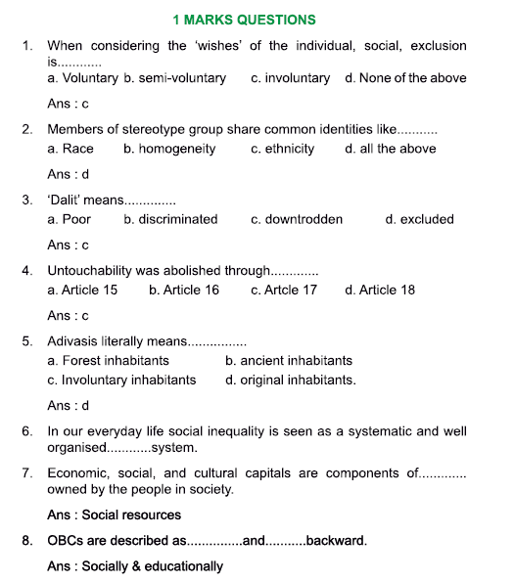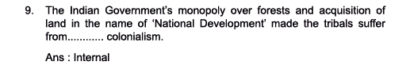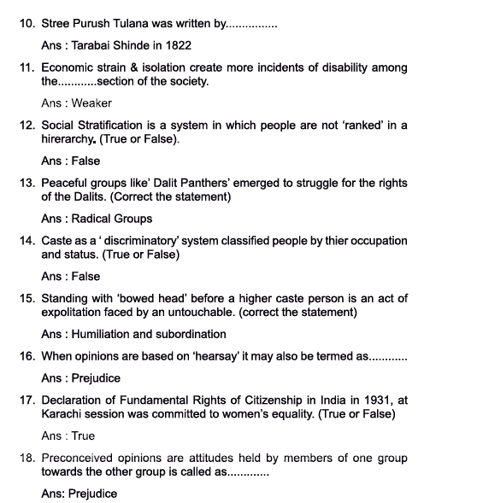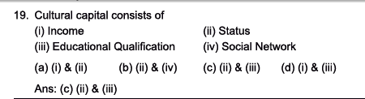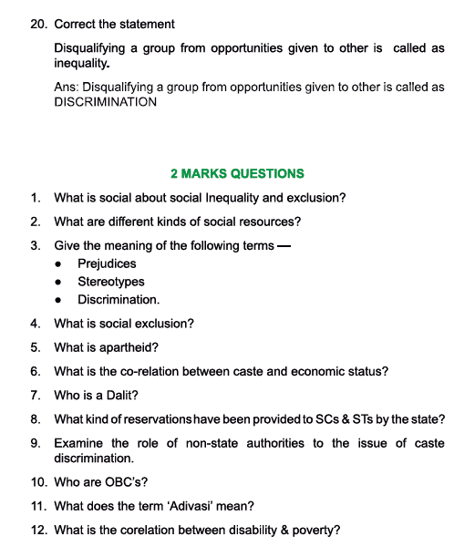
ASNWERS:
- First, social inequality and exclusion are social because they are not about individuals but about groups. Second, they are social in the sense that they are not economic, although there is usually a strong link between social and economic inequality.
- 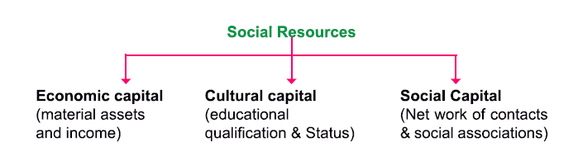
- 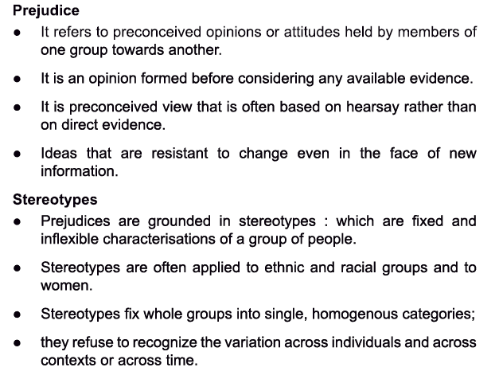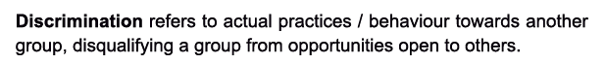
- 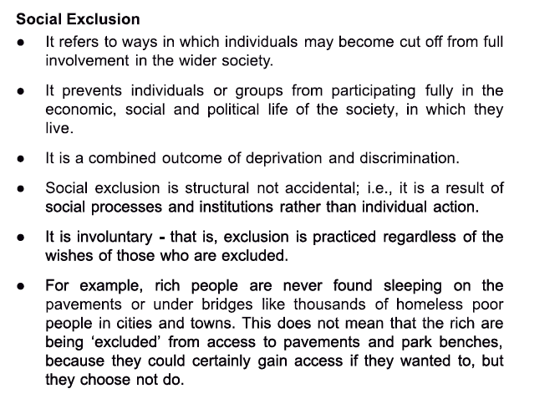
- Discrimination based on the colour of skin and race is known as apartheid. It was practised in South Africa between 1948-1994 by the white minority government over the native population.
- According to the hierarchy of caste system each class has a specific place and social status in the society. The caste system is very closely related to the economic status and the economic inequality persistent in the society.
- Untouchable, also known as Dalit, and originally Harijan, is a term used in traditional Indian society to refer to members of a variety of low-caste Hindu groups as well as people who do not belong to the caste system.8. 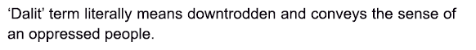
9.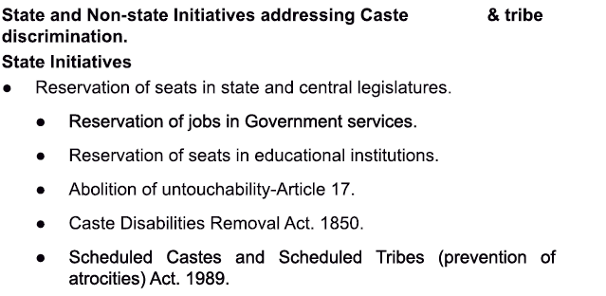
10. 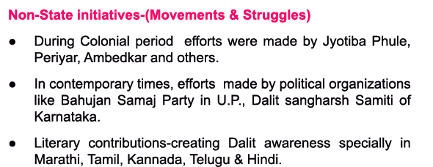

11. 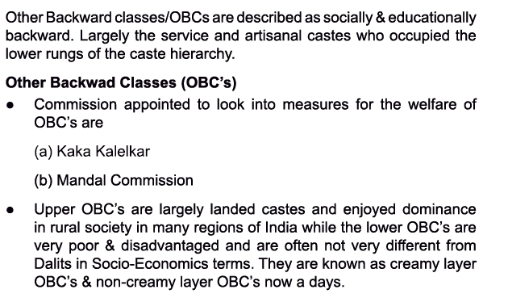
12.

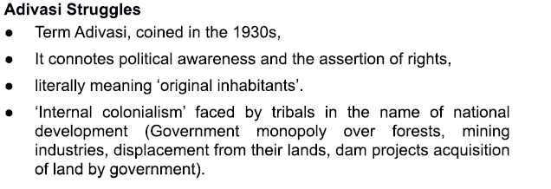

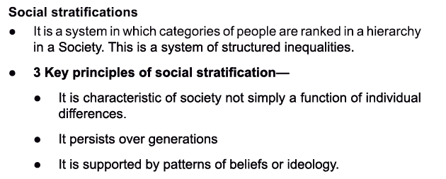
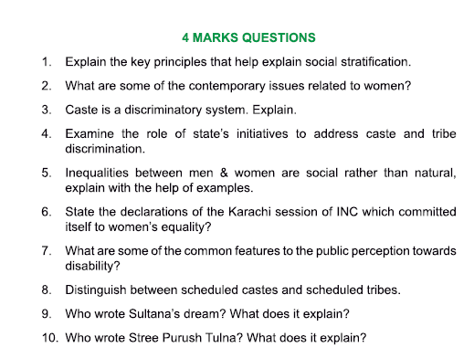

ANSWERS:
3. 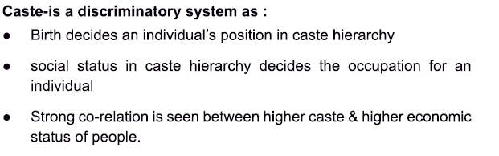
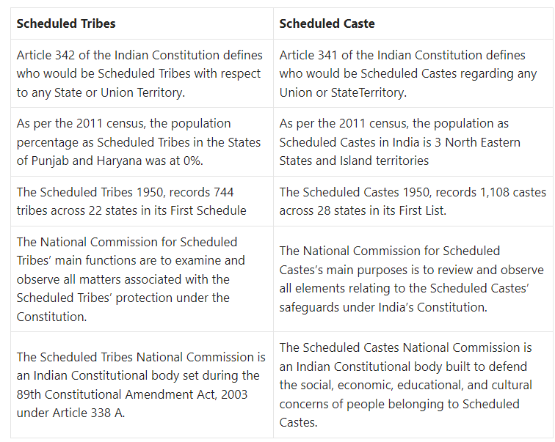

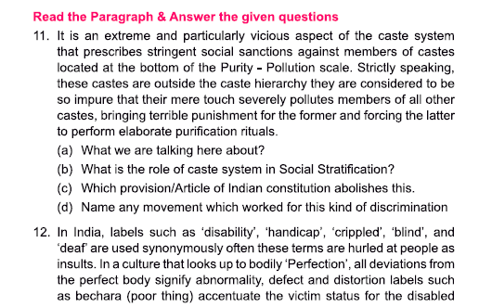
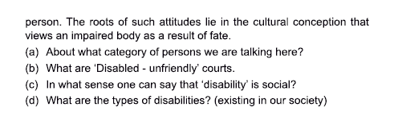
ANSWERS:

